**How do *Volvox aureus* change its movement depending on the salt concentration?**

**A global overview of sensors in living organisms**

Through evolution, sensors have been selected and organisms interact with the environment thanks to these sensors. Some organisms sense light, gravity or pressure. In the domain of Eukarya, some remarkable species are often studied to understand mechanisms that make them unique. The interest that researchers have for *Volvox aureus*, a protist,increases with time. They are really close to *Chlamydomonas[1]*, another algae, but one main thing differentiate them: *Volvox* leaves in colony where individual cell organisms become a multicellular organism, whereas *Chlamydomonas* live only in cooperation with the other cells of the colony. To explore the origin of multicellularity, it’s important to understand the similarities between *Volvox* and *Chlamydomonas* and what differences can lead to a cooperation of individual cells. Many studies have been conducted on *Volvox* cell differentiation and hydrodynamics properties[2]-[3]. However *Volvox aureus*, because of its endemic conformation of coenobium[4], is also an interesting case to study osmosis. We will here report a research we conducted on *Volvox aureus* motility in function of NaCl concentration. We have shown that the higher the concentration is, the less *Volvox aureus* move. However this study lacks of replicates and repetitions, and doesn’t explain the phenomena at a microscopic scale.

**A specific organism called *Volvox aureus***

For the last week of Biosensors, we were free to choose our own topic of research. We decided to work on *Volvox aureus*: *Volvox* is an algae living in freshwater. *Volvox aureus* forms a colony between 100 and 6000 microns. The individuals are on the boundary of the colony and linked between each other by extra cytoplasm and a gelatinous substance called mucilage. Inside of a single colony there are daughter colonies, coming from asexual reproduction. *Volvox aureus* are also capable to proceed sexual reproduction if their is an oxidative stress[5]. The colony is polar: the posterior pole is specialized in asexual reproduction when the colony is mature and the anterior pole is specialized to locate light thanks to a red eyespot[6]. Each individual possesses two flagella.

As many algae, to thrive in freshwater *Volvox* has to regulate the water flow in and out of its organism depending on the salt gradient of its medium. *Volvox aureus* has two contractile vacuoles inside the colonies that expels the water outside the colonies.

In our experiment, we wanted to know how salinity concentration in the medium would affect osmosis, supposing osmosis would have an impact on *Volvox aureus* movement: the change in form of each colony’s external wall could influence flagellar regulation of movement in the medium.

**How to know if *Volvox aureus* has a sensors for NaCl gradient?**

We wanted to see *Volvox aureus* moving, so we couldn’t use a regular slide without crushing them. This is the reason why we used a 10 counting chamber slide, normally used to count cells. We then used binocular loupes with x10 magnification: this allowed us to see all the slides and enough *Volvox* to distinguish them.

In order to make the *Volvox aureus* moving*,* we used a blue light stimulus. *Volvox* are positive phototactic for blue light. We use a blue led ( λ = 420 ) at an intensity of 300 lux and at a distance of 3.5cm from the counting chamber slide. As the blue light was insufficient to observe *Volvox aureus* under the binocular loupes and that the eyespot of *Volvox aureus* are less sensitive to red light we put a red filter ( λ = 530 ) between the white light of the binocular loupes and the plates. This allowed us to observe *Volvox.* We did the experiment under a wooden box to prevent other incoming light.

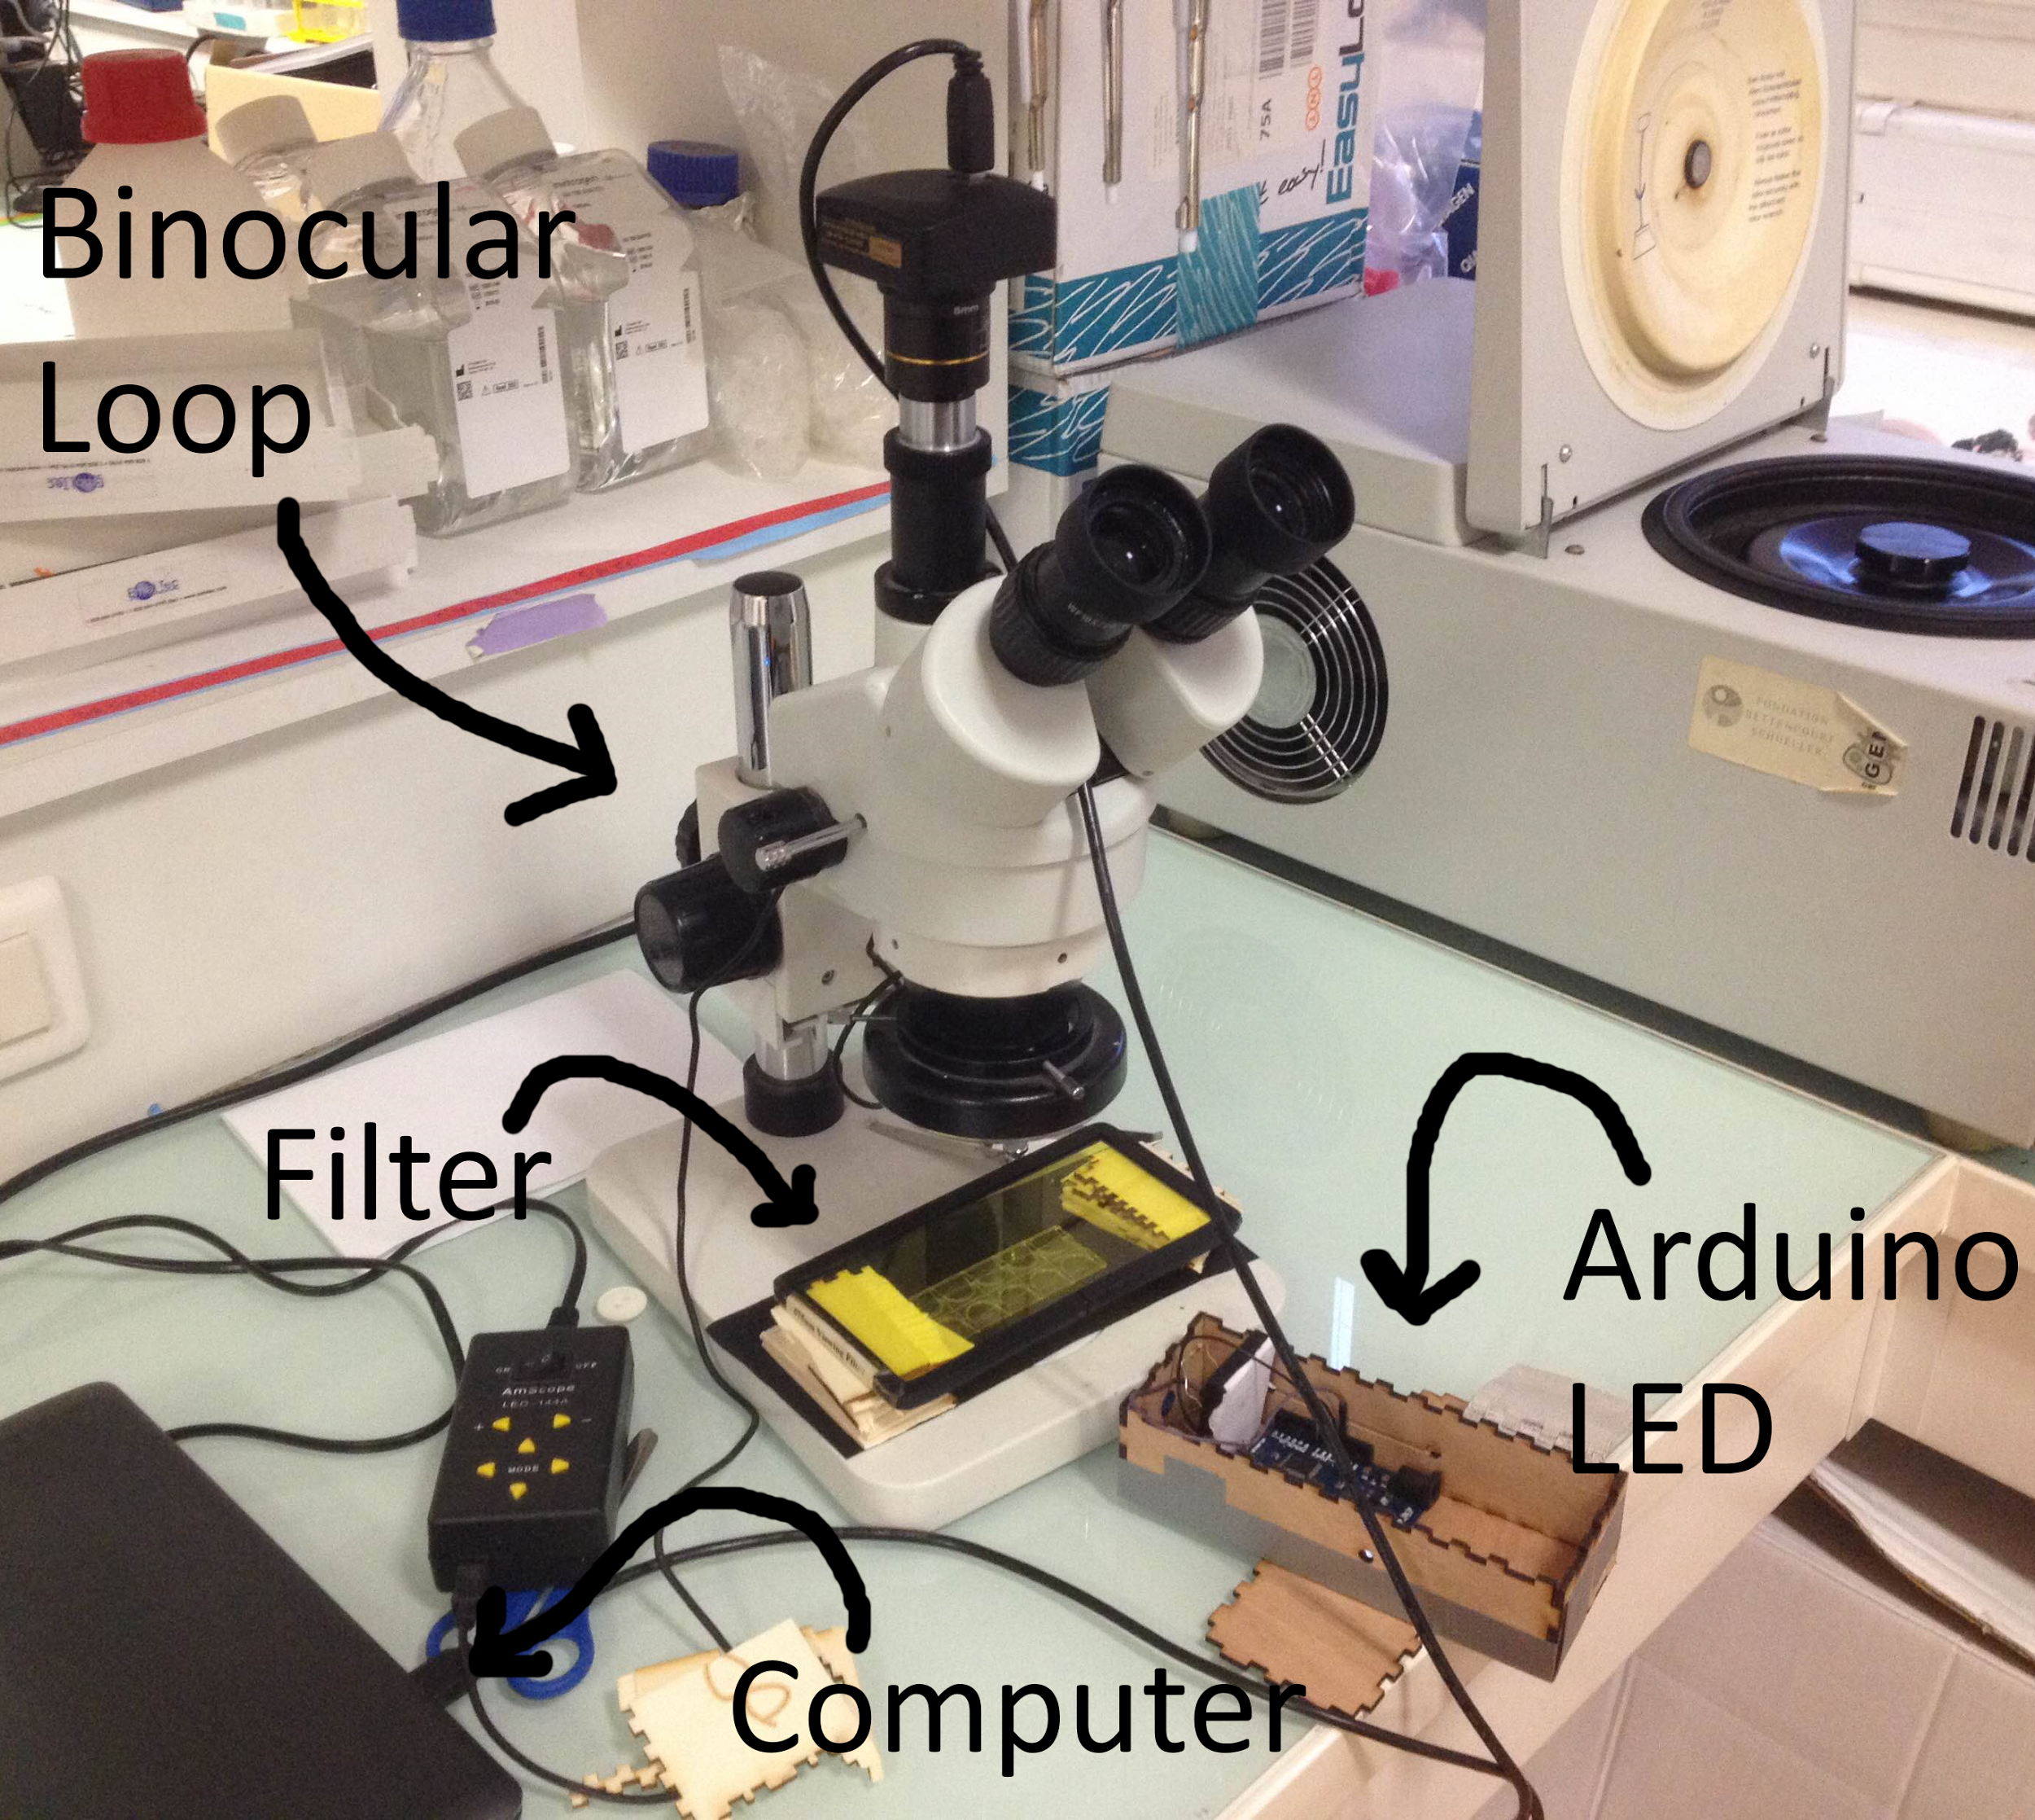

**Figure I**: Picture of the setup used to observe *Volvox aureus*. The Binocular loupes have x10 of magnification. The Filter (~530 nm) is used to avoid the light of the microscope blinding the algae. The Arduino led produces a blue light (~420) used to activate positive phototaxis in *Volvox aureus*.

First, we tested 5 different concentrations of salt in still water (0.01, 0.03, 0.06, 0.07, 0.08 g/L) ; positive control = 0.01 ; negative control = no salt. Secondly, we used around 5 *Volvox* for each concentration and we did 2 replicates. Finally, the movement of Volvox in the cell slides has been recorded for 1 minutes and analyzed with imageJ thanks to its plugin manual tracking.

**Result and discussion of the quantification of *Volvox aureus* sensing NaCl**

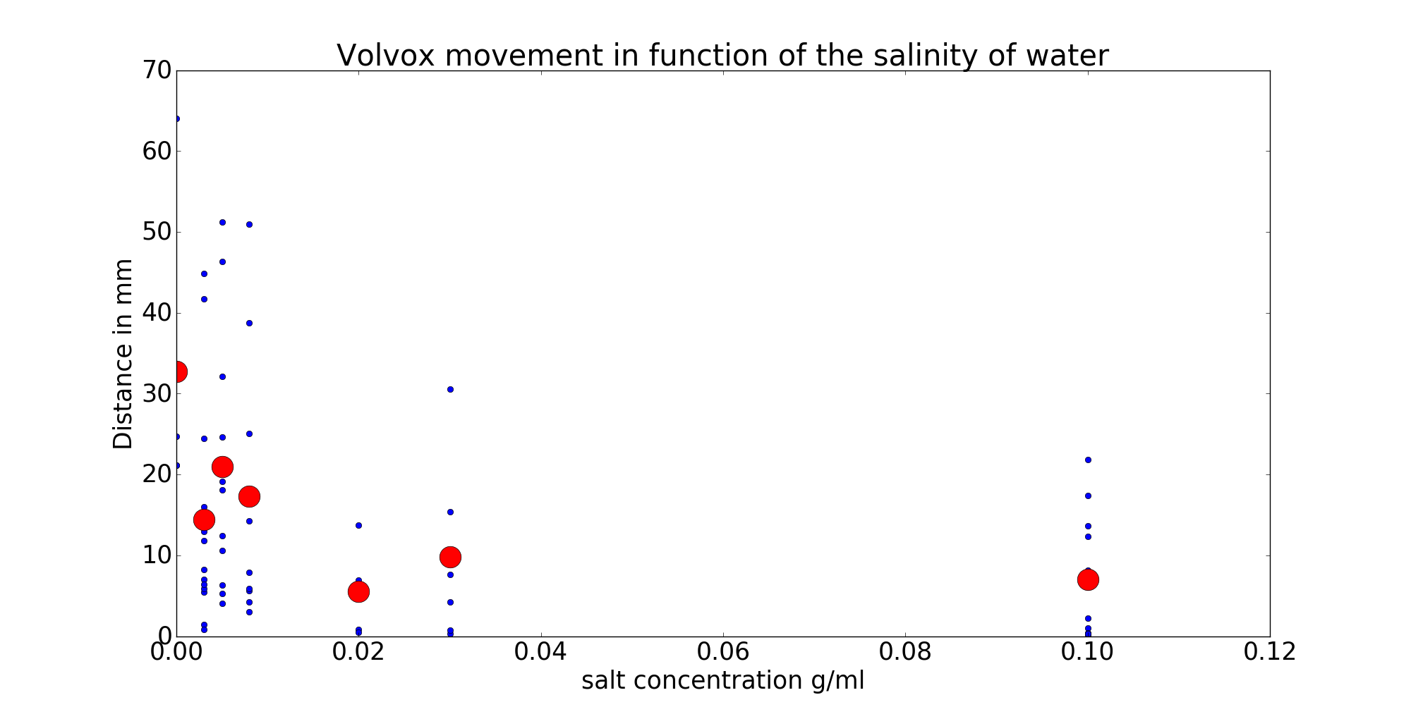

**Fig1 : motility according to the salt concentrations**: blue points represent the motility of each *Volvox*. Red points are the mean of all *Volvox* at the same concentration of salt. The motility of *Volvox* decreases the more salt there is in the media. The trend is not clear between 0 and 0.02 g.mL.

We can see that salt has a real impact on *Volvox* motility. However, the reasons of the slow-down of this mobility are unclear.

The first hypothesis is a changement of the shape of *Volvox* due to osmosis.

However, like *Chlamydomonas, Volvox* have a cell wall which prevent too much loss or gain of water due to osmosis[7]. So, the cell doesn’t shrink or explode.

Besides,*Volvox* also has a contractile vacuole: this contractile vacuole expels the surplus of water from the cell in the media. This process needs energy. We can roughly hypothesise that as the cell use energy to balance its osmosis, it has less energy to move its flagella, thus there is less movement.

A study of 19798[8]  also observed a diminution of the velocity the more the concentration of salt is important. In this study, Sakaguchi suggests that the loss of velocity of *Volvox* is linked to the concentration of NaCl and CaCl in the medium. He also noticed that other ionic media like NCl doesn’t have an effect on the velocity. By consequence, we can suppose that osmosis doesn’t have a direct effect on the velocity of *Volvox aureus*. But does the concentration of NaCl have a direct impact on the metabolism of motility in *Volvox aureus* ?*Volvox* are protist and have eukaryotic flagella. The eukaryotic flagellum moves thanks to dynein, a protein motor. So, NaCl seems not to have a direct impact on the movement of flagella. However, due to the utilisation of ATP to keep water regulation constant, it can miss ATP for to let dynein running. We can’t determine in this research which other organelle needs more NaCl or more ATP during an osmotic pressure. The mechanism of contractile vacuoles are unknown for*Volvox*.

*Chlamydomonas* are really close to *Volvox*. We can try to understand why salt influences *Volvox* motility via *Chlamydomonas*.

A study reveals than *Chlamydomonas* can lose their flagella because of salt9[9]. After that, *Chlamydomonas* can regenerate them.

We can think that the mechanism could work for *Volvox.* In this case, the time of the experiment was too short to regenerate its flagella, and they could not move.

A second hypothesis about the flagella is not the loss of them, but the movement of the flagella is slower. This means that there is less energy left for the flagella.

We can make sure of that by observing directly the flagella of *Volvox.* However, our microscope was not enough powerful.

More experiments with different intensities of led are needed to see if the trend of the curve is the same.

To conclude, the sample size of this experiment is very insufficient and we can’t make any statistical test.

**How to conclude and continue this research**

The motility of *V. aureus* depends on NaCl concentration in the medium. However, the understanding of this phenomenon needs more experiments. There are a lot of mechanisms that can be explained in this relation between NaCl and *Volvox.* We have to considerer the impact of salt on the different organelles that have an influence on motility. We also can use the genetic proximity of *Volvox* and *Chlamydomonas* to focus more easily on key organelles, considering *Chlamydomonas* are model organism and are pretty known.

1. « Volvox, Chlamydomonas, Evolution of Multicellularity | Learn Science at Scitable ». Consulted 9/02/2017 http://www.nature.com/scitable/topicpage/volvox-chlamydomonas-and-the-evolution-of-multicellularity-14433403.
2. « Heat shock elicits production of sexual inducer in Volvox | Science ». Consulted 3/02/2017. http://science.sciencemag.org/content/231/4733/51.long.
3. « DancingVolvox: Hydrodynamic Bound States of Swimming Algae - waltzing.pdf ». 12/02/2017. http://www.damtp.cam.ac.uk/user/gold/pdfs/waltzing.pdf.
4. « Volvox: Occurrence, Structure and Reproduction (With Diagrams) ». Consulted 12/02/2017. http://www.biologydiscussion.com/algae/life-cycle-algae/volvox-occurrence-structure-and-reproduction-with-diagrams/21149.
5. « Sex as a response to oxidative stress: a twofold increase in cellular reactive oxygen species activates sex genes | Proceedings of the Royal Society of London B: Biological Sciences ». Consulted 3/02/2017. http://rspb.royalsocietypublishing.org/content/271/1548/1591.
6. « Volvox: Occurrence, Structure and Reproduction (With Diagrams) ». *Biology Discussion*, 4/02/2016. http://www.biologydiscussion.com/algae/life-cycle-algae/volvox-occurrence-structure-and-reproduction-with-diagrams/21149.
7. « Nucleated assembly of Chlamydomonas and Volvox cell walls ». *The Journal of Cell Biology* 105, no 5 (1 novembre 1987): 2373‑82.
8. Hironobu Sakaguchi “ « Effect of external ionic environment on phototaxis of *Volvox carteri* » *Plant and Cell physiol* 20 (1979)
9. Johnson, K. A., et J. L. Rosenbaum. « Flagellar Regeneration in Chlamydomonas: A Model System for Studying Organelle Assembly ». *Trends in Cell Biology* 3, no 5 (mai 1993): 156‑61.